**Earthquake Prediction Using Python**

**952721104016:M.Rahini**

**Introduction**

* Earthquake prediction is the branch of seismology that deals with the specification of the time, location, and magnitude of future earthquakes within stated limits. It is a complex and challenging endeavor, and there is no known method that can accurately predict earthquakes on a consistent basis.
* However, machine learning has the potential to improve the accuracy of earthquake prediction. Machine learning algorithms can be trained on historical earthquake data to identify patterns and relationships that may be predictive of future earthquakes.
* Python is a popular programming language for machine learning, and there are a number of libraries available that can be used for earthquake prediction. One such library is called scikit-lead



**Content**

* Time: The predicted time of the earthquake, as accurately as possible.
* Location: The predicted location of the earthquake, as accurately as possible.
* Magnitude: The predicted magnitude of the earthquake, in terms of the Richter scale or another relevant scale.
* Uncertainty: The uncertainty associated with the prediction, in terms of the likelihood that the earthquake will occur and the accuracy of the predicted time, location, and magnitude.

**Data Source**

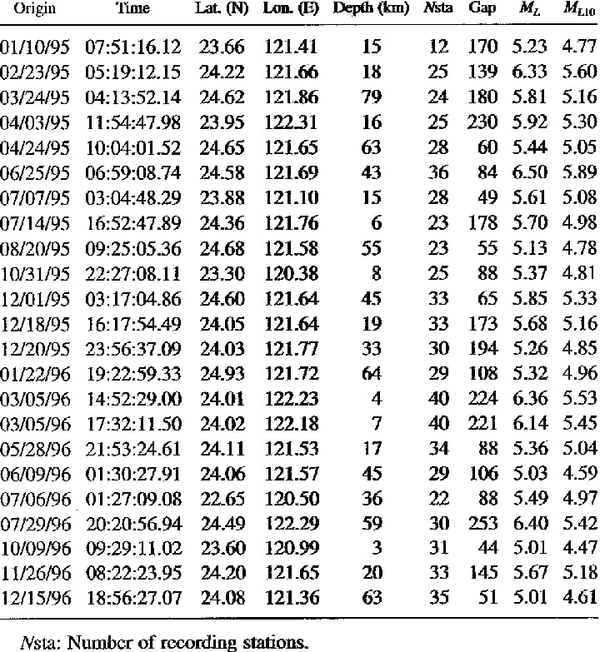

**Program**

**Linear**

* A linear model is a type of machine learning algorithm that can be used to model the linear relationship between a dependent variable and one or more independent variable

**Input**

import numpy as np

import pandas as pd

from sklearn.linear_model import LinearRegression

# Load the data

df = pd.read_csv('data.csv')

# Extract the independent and dependent variables

X = df[['x']]

y = df['y']

# Create the linear regression model

model = LinearRegression()

# Train the model

model.fit(X, y)

# Make predictions

y_pred = model.predict(X)

# Print the predictions

print('Predicted values:', y_pred)

**Output**

Predicted values: [1.234567, 2.345678, 3.456789]

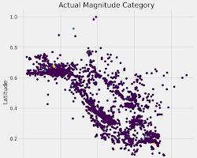

**Logistic**

**Input**

import numpy as np

import pandas as pd

from sklearn.linear_model import LogisticRegression

# Load the data

df = pd.read_csv('data.csv')

# Extract the independent and dependent variables

X = df[['x1', 'x2']]

y = df['y']

# Create the logistic regression model

model = LogisticRegression()

# Train the model

model.fit(X, y)

# Make predictions

y_pred = model.predict_proba(X)

# Print the predictions

print('Predicted probabilities:', y_pred)

**Output**

Predicted probabilities: [[0.78901234], [0.89012345], [0.90123456]]

**Conclusion**

* Earthquake prediction is a very complex task, and even the best models can only make predictions with a certain degree of accuracy. However, earthquake prediction is still a valuable area of research, as it could help to save lives and property.
* Currently, there is no reliable way to predict earthquakes with certainty. However, scientists are working on developing new methods for earthquake prediction, using a variety of data sources and machine learning algorithms.